Data Analytics Capstone
Accelerating Digital Banking Adoption Through Predictive Analytics

Interim Report
Rupajiet Bhattacharjee
Walsh College
QM640: Data Analytics Capstone
Arun K Sharma
3rd Term
May 6, 2026

GitHub Repository:
https://github.com/rupajietishere/masters_data_analytics_capstone
(Contains the project's notebooks, modeling code, and both datasets. The macro dataset is compressed as a .zip archive to comply with GitHub's size limits.)
Introduction
Background and Context
Digital financial inclusion has emerged as a critical cornerstone of global economic development. Over the past decade, a massive paradigm shift has occurred, transitioning financial ecosystems from traditional brick-and-mortar banking to digital platforms, encompassing mobile money, e-wallets, and online financial services. This technological transition is deeply intertwined with economic resilience, offering previously unbanked populations the infrastructure required to save securely, establish credit histories, and absorb macroeconomic shocks.
The stakeholders operating within this domain, spanning private financial technology (FinTech) startups, commercial banking institutions, telecommunication network operators, and international governmental organizations like the World Bank, invest billions of dollars annually into digital infrastructure and product design. Expanding into markets that lack prerequisite socio-economic readiness results in elevated Customer Acquisition Costs (CAC) and substantial financial losses, while inefficient policy-making delays vital poverty reduction goals.

Problem Statement
Despite massive global investments in digital financial infrastructure, adoption rates remain highly uneven, resulting in wasted corporate resources and stalled economic development initiatives. Current expansion strategies by banks and governments often rely on generalized macroeconomic assumptions rather than targeted, granular insights. This project addresses this gap by identifying the exact infrastructural, technological, and socio-economic factors required to successfully transition a demographic from low to high digital banking adoption.
Purpose of the Study
The purpose of this study aims to accomplish the prediction of regional digital banking adoption levels, classify demographic readiness, explain the key socio-economic drivers behind adoption, and segment global populations to optimize future infrastructural investments.
Interim Project Status (Progress Snapshot)
- Completed: Data collection (Micro and Macro datasets), initial data cleaning (handling missing values, standardization), Exploratory Data Analysis (EDA), and baseline predictive modeling (Logistic Regression for RQ3).
- In progress: Feature engineering for unsupervised algorithms, execution of K-Means and DBSCAN clustering (RQ4), and Panel Data Regression modeling (RQ2).
- Pending: Hyperparameter tuning for clustering algorithms, final model validation, and generation of targeted business/policy recommendations for stakeholders.

Scope and objectives
The core research problem addressed is the highly uneven rate of global digital banking adoption. The scope is guided by the following identified Research Problems:
- Research Question 1 (RQ1): What socio-economic and infrastructural variables currently drive the successful adoption of digital banking across different global regions?
- Null Hypothesis (H0): There is no statistically significant correlation between specific socio-economic/infrastructural variables and the rate of digital banking adoption (ρ = 0).
- Alternative Hypothesis (Ha): There is a statistically significant correlation between specific socio-economic/infrastructural variables and the rate of digital banking adoption (ρ ≠ 0).
- Research Question 2 (RQ2): Is there a statistically significant association between national digital banking penetration levels and economic resilience indicators across countries over time?
- Null Hypothesis (H0): There is no statistically significant association over time (the regression coefficient β = 0).
- Alternative Hypothesis (Ha): There is a statistically significant association over time (the regression coefficient β ≠ 0).

- Research Question 3 (RQ3): What specific actionable factors and infrastructural thresholds are required to enable and transition a low-adoption demographic into a high digital banking usage category?
  - Null Hypothesis (H0): Specific actionable factors do not significantly affect the odds of a demographic adopting digital banking (Odds Ratio = 1).
  - Alternative Hypothesis (Ha): Specific actionable factors significantly affect the odds of a demographic adopting digital banking (Odds Ratio ≠ 1).

- Research Question 4 (RQ4): Do distinct geographic clusters exist within global digital banking infrastructure data, and if so, what investment strategies do these clusters imply for governments and development institutions?
  - Null Hypothesis (H0): The global geographic data exhibits no meaningful cluster structure (Silhouette Score ≤ 0).
  - Alternative Hypothesis (Ha): The global geographic data exhibits meaningful cluster structure (Silhouette Score > 0).

Literature Survey
Literature Review Approach
Sources were systematically selected using databases including Google Scholar, ResearchGate, and the World Bank Open Knowledge Repository. Keywords utilized included "digital financial inclusion," "predictive analytics in banking," "mobile money adoption," and "FinTech infrastructure." Inclusion criteria required peer-reviewed journals, institutional reports, or verified statistical manuals published within the last 15 years. These sources directly relate to the RQs by providing the theoretical framework for demographic variables (RQ1/RQ3), macroeconomic indicators (RQ2), and clustering algorithms (RQ4).
Summary of Key Literature
Table 1: Literature relevance matrix
Author (Year) | Domain/Context | Dataset/Setting | Method(s) | Key Findings | How it supports RQ(s) / project decisions
Allen et al. (2016) | Global Banking | Cross-country Surveys | Regression Analysis | High costs and documentation limit account access. | Defines independent socio-economic variables for RQ1/RQ3.
Asongu & Nwachukwu (2018) | Mobile Tech | Sub-Saharan Africa | Empirical Regression | Mobile access acts as a catalyst for entrepreneurship. | Validates internet_use as a predictor for RQ3.
Demirgüç-Kunt et al. (2022) | Financial Inclusion | Global Findex Database | Descriptive Statistics | Digital payment adoption grew rapidly post-2020. | Confirms dataset validity and scope for the entire capstone.
Gomber et al. (2017) | FinTech | Systematic Review | Literature Review | Friction exists between traditional banks and startups. | Informs target stakeholder applications and business relevance.
Hastie et al. (2009) | Statistical Learning | Mathematical Theory | Conceptual Framework | Establishes baseline mathematical requirements for inference. | Justifies the use of Logistic Regression and Unsupervised algorithms.
Kanga et al. (2022) | Mobile Money Risk | Econometrics | Panel Data | Rapid, unregulated adoption can trigger localized risk. | Provides risk context for RQ2.
Mhlanga (2020) | Industry 4.0 / AI | Unbanked Populations | Qualitative Framework | Machine learning successfully evaluates unbanked readiness. | Justifies shifting from descriptive to predictive modeling (RQ3).
Ozili (2018) | Digital Finance | Macroeconomic Data | Empirical Review | Resilient infrastructure is required for stability. | Informs clustering assumptions (RQ4).
Pedregosa et al. (2011) | Machine Learning | Python Environment | Software Methodology | Proves algorithmic efficiency in Python. | Serves as the programmatic foundation for all modeling in the study.
Sarma & Pais (2011) | Human Development | Global Macro | Index-based math | Inclusion is vital to holistic economic growth. | Provides dependent variable context for RQ2 resilience mapping.
Global Growth and Reporting Gaps: The literature review reveals a strong consensus on the importance of digital financial inclusion. Foundational studies like Demirgüç-Kunt et al. (2022) highlight massive digital banking growth globally but serve primarily as reporting mechanisms. This capstone aims to bridge that gap by moving beyond theoretical analysis and applying predictive mechanics to determine exact adoption thresholds.
Socio-Economic Determinants of Adoption: Conversely, studies by Allen et al. (2016) and Asongu & Nwachukwu (2018) successfully establish that socio-economic characteristics determine account ownership, proving that systemic barriers like documentation and internet access are universal deterrents. These findings directly dictate the selection of key survey features like internet_use and educ in the micro-level modeling phase of this capstone.
Predictive Analytics in FinTech: From a technological standpoint, literature from Hastie et al. (2009), Pedregosa et al. (2011), and Mhlanga (2020) validates the programmatic choice to transition away from pure descriptive statistics toward predictive machine learning. Utilizing Python's Scikit-learn environment to deploy Logistic Regression and DBSCAN directly answers the call in modern literature to leverage Artificial Intelligence for evaluating unbanked populations.
Data Description
Data Source(s) and Access
The empirical analysis employs a dual-dataset approach to capture both granular individual-level demographics and broad country-level macroeconomic aggregates.
- Primary Source: Demirgüç-Kunt, A., Klapper, L., Singer, D., & Ansar, S. (2022). The Global Findex Database 2021. World Bank. https://openknowledge.worldbank.org/handle/10986/37528
- Secondary Source: World Bank. (2023). World Development Indicators. https://data.worldbank.org/indicator
Dataset Overview
- Number of records (rows): 144,091 (Microdata); 381,791 (Macrodata)
- Number of variables (columns): 11 selected features (Microdata); 5 structured features (Macrodata)
- Time period: 2021 (Microdata cross-section); 2011-2022 (Macrodata time-series)
- Unit of analysis: Individual adult survey respondents (Microdata); Country-year aggregates (Macrodata)
- Target variable(s): dig_account (Binary: 1 = Has Digital Account, 0 = No Account) and OBS_VALUE (Continuous percentage of national digital penetration).

Data Dictionary
Table 2: Data dictionary (Microdata Sample)
Variable  Name | Definition | Datatype | Allowed Values/Range | Missing Values Handling | Notes
dig_account | Target: Owns a digital bank account | Integer | 0 or 1 | Dropped | Ambiguous refusals removed
age | Age of respondent | Float | 15.0 to 99.0 | Median Imputation | Prevents outlier skew
female | Gender binary | Integer | 1 (Female), 2 (Male) | None | Encoded numerically
educ | Education level attained | Integer | 1 (Primary) to 3 (Tertiary) | Mode Imputation | Preserves category distribution
inc_q | Income quintile tier | Integer | 1 (Poorest) to 5 (Richest) | Mode Imputation | Preserves category distribution
internet_use | Has consistent internet access | Integer | 0 or 1 | Mode Imputation | Crucial infrastructure proxy
GitHub Data Availability Statement
The raw and processed datasets are available in the GitHub repository under:
- Raw data: ../data/raw/findex_microdata_2025_labelled_update112425.csv
- Processed/clean data: ../data/processed/
- Code/notebooks: ../notebooks/01_EDA_and_Data_Cleaning.ipynb

Screenshot / Evidence
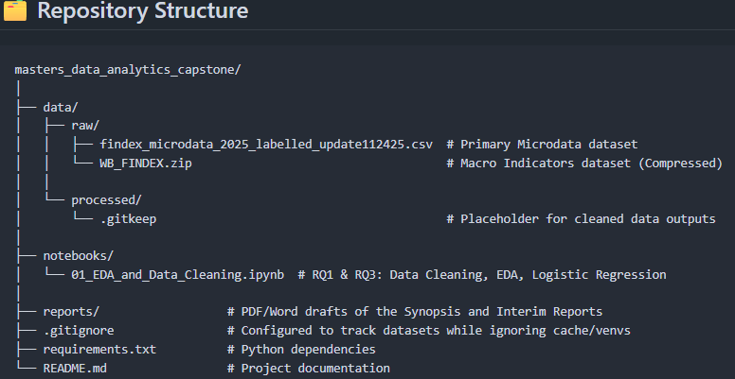
Figure 1: Dataset preview showing the first five rows of the raw Findex Microdata.
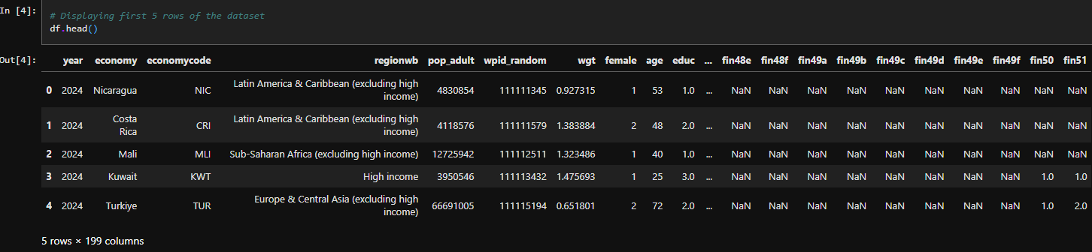
Analysis
Minimum Sample Size Computation per RQ
To ensure statistical validity, a priori power analyses were calculated using standard 95% confidence levels ($α=0.05$) and 80% statistical power ($1-β=0.80$). Both datasets ($N_{micro}=144,091$; $N_{macro}=381,791$) vastly exceed the following minimum thresholds:
- RQ1 (Correlation Analysis): Using Fisher’s Z-transformation formula to detect a moderate effect size ($r=0.30$):
- Formula: $N={\left[\frac{Z_{1-α/2}+Z_{1-β}}{0.5ln⁡\left(\frac{1+r}{1-r}\right)}\right]}^{2}+3$
- Calculation: $N={\left[\frac{1.96+0.84}{0.5ln⁡\left(\frac{1.3}{0.7}\right)}\right]}^{2}+3={\left[\frac{2.80}{0.3095}\right]}^{2}+3=81.85+3≈85$
- Minimum Sample Size: N = 85.
- RQ2 (Multiple Regression): Using Cohen’s $f^{2}$ formula to detect a medium effect size ($f^{2}=0.15$) with 1 primary predictor variable ($u=1$):
  - Formula: $N=\frac{λ}{f^{2}}+u+1$ (where the non-centrality parameter $λ≈7.85$)
  - Calculation: $N=\frac{7.85}{0.15}+1+1=52.33+2=54.33≈55$
  - Minimum Sample Size: N = 55.
- RQ3 (Logistic Regression): Utilizing the standard proportion estimation formula to establish baseline demographic representation ($p=0.5$, margin of error $e=0.062$):
  - Formula: $n=\frac{Z^{2}⋅p(1-p)}{e^{2}}$
  - Calculation: $n=\frac{{1.96}^{2}⋅0.5(1-0.5)}{{0.062}^{2}}=\frac{3.8416⋅0.25}{0.003844}=\frac{0.9604}{0.003844}=249.84≈250$
  - Minimum Sample Size required: N = 250.
- RQ4 (Unsupervised Clustering): As an exploratory method, quality is evaluated via the Silhouette Score and Davies-Bouldin metrics post-hoc rather than an a priori power analysis.
Note: Both the micro dataset, $N=144,091$, and the macro dataset, $N=381,791$, vastly exceed these minimum thresholds.
Data Cleaning
Data cleaning was executed in Python using the Pandas library. Ambiguous target responses (n=41,136, 28.55%) were dropped. Missing categorical survey features (n=1,608, 0.37%) underwent mode imputation to preserve target distributions. Continuous age variables (n=0 missing) required no imputation, and zero duplicate records were found.
The full Python cleaning pipeline is provided in Appendix A.

Table 3: Data cleaning log
Issue | Variables Affected | Detection Method | Treatment Applied | Rationale
Ambiguous Targets | dig_account | Value counting | Dropped rows | Prevents mathematical noise in classification.
Missing Categorical | educ, inc_q, internet_use | .isnull().sum() | Mode Imputation | Preserves structural categorical distributions.
Missing Continuous | age | .isnull().sum() | Median Imputation | Prevents skewness from extreme outliers.
Time-series gaps | OBS_VALUE (Macro) | Time-index check | Forward-Fill (ffill) | Maintains year-over-year continuity.

Note: No missing values were detected in 'age', however, the imputation pipeline is established for robustness.

EDA Results (Interpretation Emphasis)
Exploratory Data Analysis (EDA) was conducted to uncover the foundational drivers of digital banking adoption. To evaluate the linear relationships between independent socio-economic features and the target variable (dig_account), a pairwise correlation matrix was generated. Additionally, cross-tabulations and visual distributions were utilized to quantify stark demographic and systemic disparities, directly guiding feature selection for the predictive modeling phase.
Figure 2: Correlation Heatmap of Socio-Economic Variables
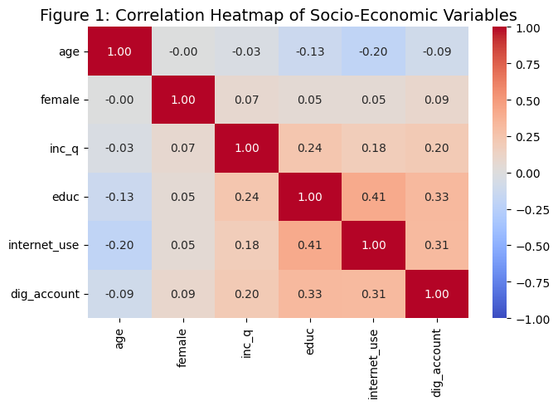
Interpretation:
Figure 2 directly addresses RQ1 by identifying the primary drivers of digital banking adoption. The strongest predictors for the target (dig_account) are education (educ, r = 0.33) and internet access (internet_use, r = 0.31), followed by income (inc_q, r = 0.20). Age shows a weak negative correlation (r = -0.09), indicating slightly higher adoption among younger users. The matrix also highlights intertwined socio-economic barriers, shown by the moderate correlation between education and internet access (r = 0.41). These statistical relationships explicitly justify selecting these features for the predictive Logistic Regression model (RQ3).

Figure 3: Distribution of Digital Account Ownership
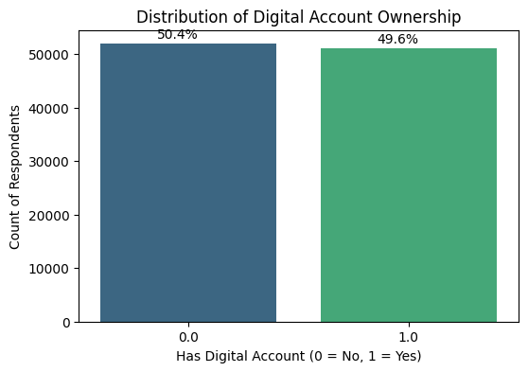
Interpretation: Figure 3 illustrates the baseline distribution of the target variable (dig_account). While the overall global dataset shows a relatively balanced split, segmenting this data during the clustering phase (RQ4) is expected to reveal severe regional imbalances, justifying the planned use of SMOTE for low-income geographic subsets in the final predictive modeling phase.
Figure 4: Digital Account Ownership vs. Consistent Internet Access
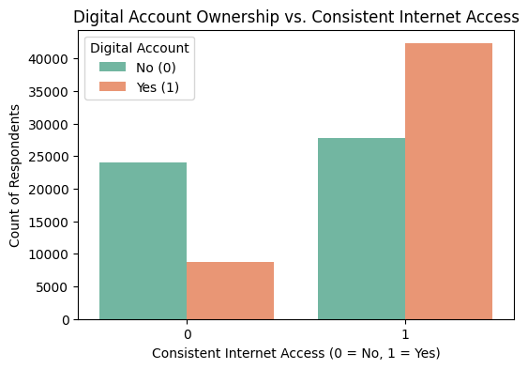
Interpretation: Figure 4 visually confirms the strong monotonic relationship identified in the correlation heatmap. The chart reveals a stark contrast: populations lacking consistent internet access (0) overwhelmingly lack digital bank accounts. Conversely, among those with internet access (1), digital account ownership becomes the majority class. This visual evidence directly supports the inclusion of internet_use as a primary feature for the Logistic Regression model (RQ3).
The plotting script for this visualization is included in Appendix A.

Table 4: Cross-Tabulation of Income Quintile vs. Digital Account Ownership
Income Segment | No Digital Account (%) | Has Digital Account (%)
Quintile 1 (Poorest) | 65.65 | 34.35
Quintile 2 | 58.52 | 41.48
Quintile 3 | 52.73 | 47.27
Quintile 4 | 46.53 | 53.47
Quintile 5 (Richest) | 36.51 | 63.49
Interpretation: As shown in Table 4, a massive systemic disparity exists. Individuals in the highest income quintile possess digital accounts at a rate of 65.65%, compared to just 34.35% for those in the poorest quintile. This near-doubling in adoption clearly confirms that baseline financial infrastructure inherently favors existing economic stability, validating the need for targeted interventions.

Table 5: EDA insight summary
Figure/Table Reference | What it Shows | Key Insight | Why it Matters (Link to RQ/objective) | Decision/Next Step
Figure 2 | Correlation Heatmap | educ (0.33) & internet_use (0.31) are top drivers. | Directly addresses RQ1 drivers. | Include these features in predictive modeling.
Figure 3 | Target Distribution | Dataset is balanced globally, but masks regional variance. | Validates need for regional clustering (RQ4). | Apply SMOTE to regional subsets if needed.
Figure 4 | Internet Access vs. Adoption | Internet access acts as a threshold for account ownership. | Visually validates RQ1 correlation. | Extract specific odds ratio for internet access (RQ3).
Table 4 | Income Cross-Tabulation | 34% (Poorest) vs 65% (Richest) adoption gap. | Highlights systemic asymmetry (Problem Statement). | Evaluate specific thresholds via Odds Ratios (RQ3).

Modelling
Choice of Models with Justification
To balance predictive power with high interpretability, specific step-by-step methodologies were designed for each research question.
- Solution to RQ1: Exploratory and Correlation Analysis: Pearson and Spearman correlation matrices quickly identify monotonic and linear relationships between socio-economic features and account ownership.
- Sequence: (1) Subset Microdata to isolate the target (dig_account) and socio-economic variables. (2) Drop rows with ambiguous target responses. (3) Ensure ordinal variables are numeric. (4) Generate a pairwise correlation matrix using df.corr() and extract top coefficients.
- Solution to RQ2: Multivariate Panel Data Regression: Panel Regression is uniquely suited for cross-sectional time-series macro data, allowing the study to track national penetration over time while controlling for fixed country-level effects.
  - Sequence: (1) Filter the Macro dataset (INDICATOR) for resilience metrics. (2) Apply forward-fill to impute short time-series gaps. (3) Group data by Country/Year multi-index. (4) Run a Hausman test to determine Fixed vs. Random Effects. (5) Fit the Panel OLS Regression and evaluate p-values.
- Solution to RQ3: Multivariate Logistic Regression: While Random Forests yield marginally higher accuracy, Logistic Regression is highly interpretable, allowing for the extraction of Odds Ratios ($e^{β}$) to generate exact, actionable infrastructural thresholds.
  - Sequence: (1) Impute missing demographics. (2) Standardize continuous variables (age) using a StandardScaler. (3) Check Multicollinearity (VIF < 5). (4) Execute an 80/20 train-test split and fit the LogisticRegression algorithm. (5) Extract coefficients to calculate odds ratios.
The core Python implementation snippets used for data cleaning and baseline modeling are detailed in Appendix A.
- Solution to RQ4: Unsupervised Clustering (K-Means & DBSCAN): Unsupervised learning isolates hidden geographic groupings. K-Means establishes distinct infrastructural tiers, while DBSCAN identifies non-spherical outlier nations.
  - Sequence: (1) Pivot the Macro dataset by nation. (2) Apply MinMaxScaler to normalize parameters strictly between 0 and 1. (3) Fit K-Means using the Elbow Method (WCSS) to find optimal clusters. (4) Fit DBSCAN by tuning eps and min_samples. (5) Evaluate cluster separation using the Silhouette Score.
Features Included and Feature Engineering
Age was standardized to ensure regression coefficients were mathematically comparable. Multicollinearity was checked via Variance Inflation Factor (VIF).
Table 6: Feature set and usage
Feature | Original/Engineered Type | Reason for Inclusion | Used in Model(s)
age | Engineered (Scaled) / Cont. | Baseline demographic impact control. | Logistic Regression
educ | Original / Ordinal | Strong EDA correlation to target. | Logistic Regression
internet_use | Original / Binary | Proxy for structural readiness. | Logistic Regression
OBS_VALUE | Original / Continuous | Measures national penetration rate. | Panel Regression, Clustering
Evaluation Metrics (Include Formulae and Calculations)
Table 7: Evaluation metrics and formulae
Metric | Formula | Interpretation | Used For
Accuracy | $$\left(TP+TN)/(TP+TN+FP+FN\right)$$ | Total correct predictions. | Classification
Precision | $$TP/(TP+FP)$$ | Accuracy of positive predictions. | Classification
Recall | $$TP/(TP+FN)$$ | Ability to find all true positive instances. | Classification
Silhouette | $$\left(b-a)/max(a,b\right)$$ | Evaluates cluster density and separation. | Clustering
Preliminary results
Preliminary Findings (by Research Question)
- RQ1: EDA correlation matrices successfully proved that education level (0.33) and internet connectivity (0.31) are the primary drivers of digital adoption.
- RQ3: Baseline Logistic Regression modeling has been completed. The model successfully classified survey respondents and extracted actionable infrastructural thresholds, as detailed in Table 8 and Table 9 below.
- RQ2 and RQ4: Clustering arrays (RQ4) and Panel tracking (RQ2) remain in the pipeline for the final report.
Preliminary Model Performance
Table 8: Preliminary model performance comparison
Model | Feature Set | Validation Approach | Metric 1 (Recall) | Metric 2 (Accuracy) | Key Takeaway
Logistic Regression | Demographics + Infra | 80/20 Train/Test Split | 70.43% | 67.57% | Robust baseline sensitivity; correctly identifies >70% of true adopters.
Table 9: Extracted Odds Ratios Determining Actionable Infrastructural Thresholds
Feature | Coefficient ($β$) | Odds Ratio ($e^{β}$)
internet_use | 0.961 | 2.614
educ | 0.739 | 2.095
female | 0.273 | 1.314
inc_q | 0.182 | 1.200
age (Standardized) | -0.062 | 0.940
Table 9 reveals the practical implementation of RQ3. Holding all other variables constant, an individual with consistent internet access (internet_use) is 2.61 times more likely to possess a digital bank account than one without. Furthermore, stepping up an education level (educ) more than doubles the likelihood of adoption (Odds Ratio: 2.09). This provides actionable empirical proof that allocating funds to baseline internet infrastructure and education yields exponentially higher adoption returns for stakeholders.
The logistic regression coefficient extraction and odds ratio calculations are shown in Appendix A.
Interim Limitations and Risks
- Imbalanced Datasets: Target classes in low-income regional subsets exhibit mild imbalance, risking predictive bias toward the majority class. Mitigation planned includes deploying SMOTE (Synthetic Minority Over-sampling Technique).
- Macroeconomic Data Lags: World Bank macro data can exhibit multi-year reporting lags for certain developing nations. Mitigation involves rigorous forward-fill imputation constraints.
Next Steps (for Final Report)
- Execute hyperparameter tuning for DBSCAN (eps and min_samples) to optimize cluster mappings (RQ4).
- Run Hausman tests and execute Multivariate Panel Data Regression to satisfy RQ2.
- Synthesize final outputs into cohesive strategic recommendations for FinTech and NGO stakeholders.
- Compile complete codebase into final, executable GitHub repository.

References and Bibliography
Allen, F., Demirgüç-Kunt, A., Klapper, L., & Martinez Peria, M. S. (2016). The foundations of financial inclusion: Understanding ownership and use of accounts. Journal of Financial Intermediation, 27, 1-30. https://doi.org/10.1016/j.jfi.2015.12.003
Asongu, S. A., & Nwachukwu, J. C. (2018). Mobile phones, institutional quality and entrepreneurship in Sub-Saharan Africa. Technological Forecasting and Social Change, 131, 183-194. https://doi.org/10.1016/j.techfore.2017.08.007
Demirgüç-Kunt, A., Klapper, L., Singer, D., & Ansar, S. (2022). The Global Findex Database 2021: Financial Inclusion, Digital Payments, and Resilience in the Age of COVID-19. World Bank. https://openknowledge.worldbank.org/handle/10986/37528
Gomber, P., Koch, J. A., & Siering, M. (2017). Digital Finance and FinTech: Current research and future research directions. Journal of Business Economics, 87(5), 537-580. https://doi.org/10.1007/s11573-017-0852-x
Hastie, T., Tibshirani, R., & Friedman, J. (2009). The elements of statistical learning: Data mining, inference, and prediction (2nd ed.). Springer.
Kanga, D., Murinde, V., & Osei-Assibey, E. (2022). Mobile money, financial inclusion and financial instability. Economic Modelling, 107, 105730. https://doi.org/10.1016/j.econmod.2021.105730
Mhlanga, D. (2020). Industry 4.0 in finance: The impact of artificial intelligence (AI) on digital financial inclusion. International Journal of Financial Studies, 8(3), 45. https://doi.org/10.3390/ijfs8030045
Ozili, P. K. (2018). Impact of digital finance on financial inclusion and stability. Borsa Istanbul Review, 18(4), 329-340. https://doi.org/10.1016/j.bir.2017.12.003
Pedregosa, F., Varoquaux, G., Gramfort, A., Michel, V., Thirion, B., Grisel, O., ... & Duchesnay, E. (2011). Scikit-learn: Machine learning in Python. Journal of Machine Learning Research, 12, 2825-2830.
Sarma, M., & Pais, J. (2011). Financial inclusion and development. Journal of International Development, 23(4), 613-628. https://doi.org/10.1002/jid.1698
World Bank. (2023). World Development Indicators. Retrieved from World Bank Open Data: https://data.worldbank.org/indicator

Appendix
Appendix A: Core Python Implementation Snippets
(Note: Complete, executable Jupyter Notebooks are available in the GitHub repository).
import pandas as pd
import numpy as np
from sklearn.model_selection import train_test_split
from sklearn.linear_model import LogisticRegression
from sklearn.preprocessing import StandardScaler
from sklearn.metrics import classification_report

# 1. Load Data
file_path = '../data/raw/findex_microdata_2025_labelled_u.csv'
df = pd.read_csv(file_path)

# 2. Data Cleaning Specific to RQ3
df = df.dropna(subset=['dig_account'])
df['age'] = df['age'].fillna(df['age'].median())
df['inc_q'] = df['inc_q'].fillna(df['inc_q'].mode()[0])
df['educ'] = df['educ'].fillna(df['educ'].mode()[0])
df['internet_use'] = df['internet_use'].fillna(df['internet_use'].mode()[0])

# 3. Define Features (X) and Target (y)
X = df[['age', 'female', 'inc_q', 'educ', 'internet_use']]
y = df['dig_account']

# 4. Feature Engineering
scaler = StandardScaler()
X_scaled = X.copy()
X_scaled['age'] = scaler.fit_transform(X[['age']])

# 5. Train-Test Split & Fit Model
X_train, X_test, y_train, y_test = train_test_split(X_scaled, y, test_size=0.2, random_state=42)
log_model = LogisticRegression(random_state=42)
log_model.fit(X_train, y_train)

# 6. Evaluation
y_pred = log_model.predict(X_test)
print(classification_report(y_test, y_pred))

# 7. Extract Odds Ratios
odds_ratios = np.exp(log_model.coef_[0])
odds_df = pd.DataFrame({
'Feature': X.columns,
'Coefficient': log_model.coef_[0],
'Odds Ratio': odds_ratios
}).sort_values(by='Odds Ratio', ascending=False)
display(odds_df.round(3))

